Mastering Your Ring Performance Seminar
Presented by Lara Avery of Star Power Dog Training

September 28th & 29th,2024: Two-Day Competition Obedience Seminar
Monday September 30th, 2024: Private Lessons

Doggie U K9 Academy
1515-D 5th Industrial Ct, Bay Shore NY 11706

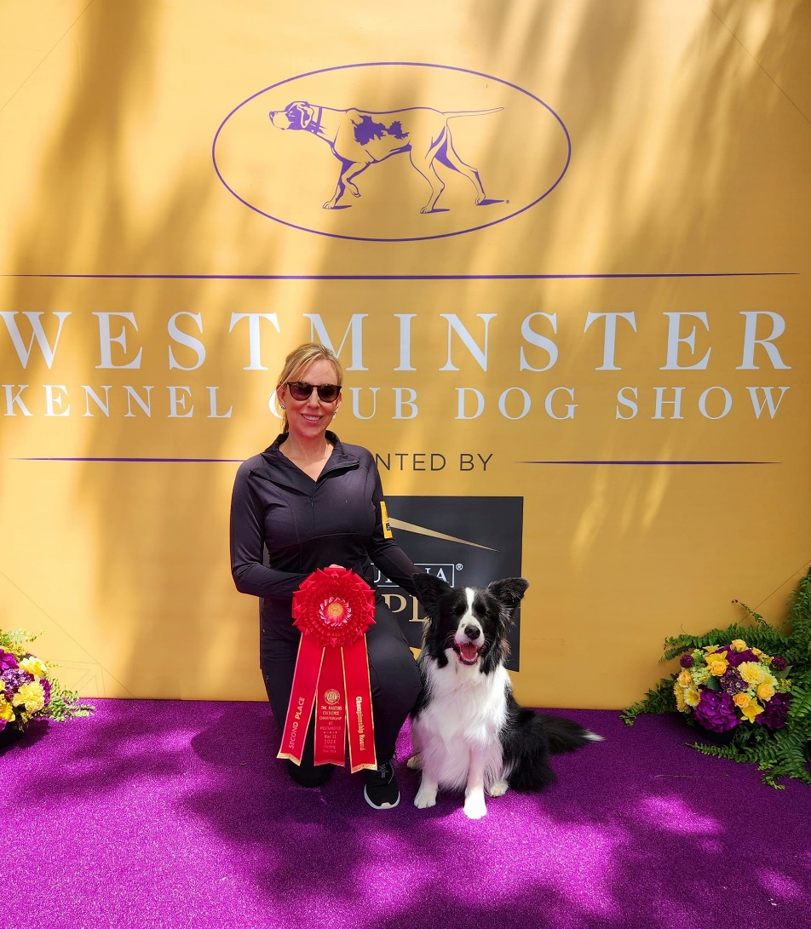
REGISTRATION OPENS MAY 28TH,2024

Lara & her dog Sailor competed just this year at the 2024 Westminster Kennel Club dog show, and they took 2nd place in a very competitive Utility class!
As well as 2nd Place Overall in the Masters Obedience Championship!

About the Seminar

Transitioning from training to trialing is one of the most difficult aspects in competition obedience. Statements such as, “my dog has always nailed this exercise in training” and “my dog is so happy in training yet falls apart at trials” are heard all too often.

During this two-day seminar, Lara will cover important topics and share her own training approach and strategies that will maximize your ring performance, including: how your training picture affects show ring performance, and how to merge those two pictures; tackling pressure and how to reduce it in the ring; proofing for confidence in the ring; how your energy can greatly affect your ring performance (and how to change your energy); why ring entrances and set ups matter, and how they can dictate your overall ring performance.
Working teams will have ample floor time with Lara to learn new strategies and help problem solve issues relating to the subject matter.

